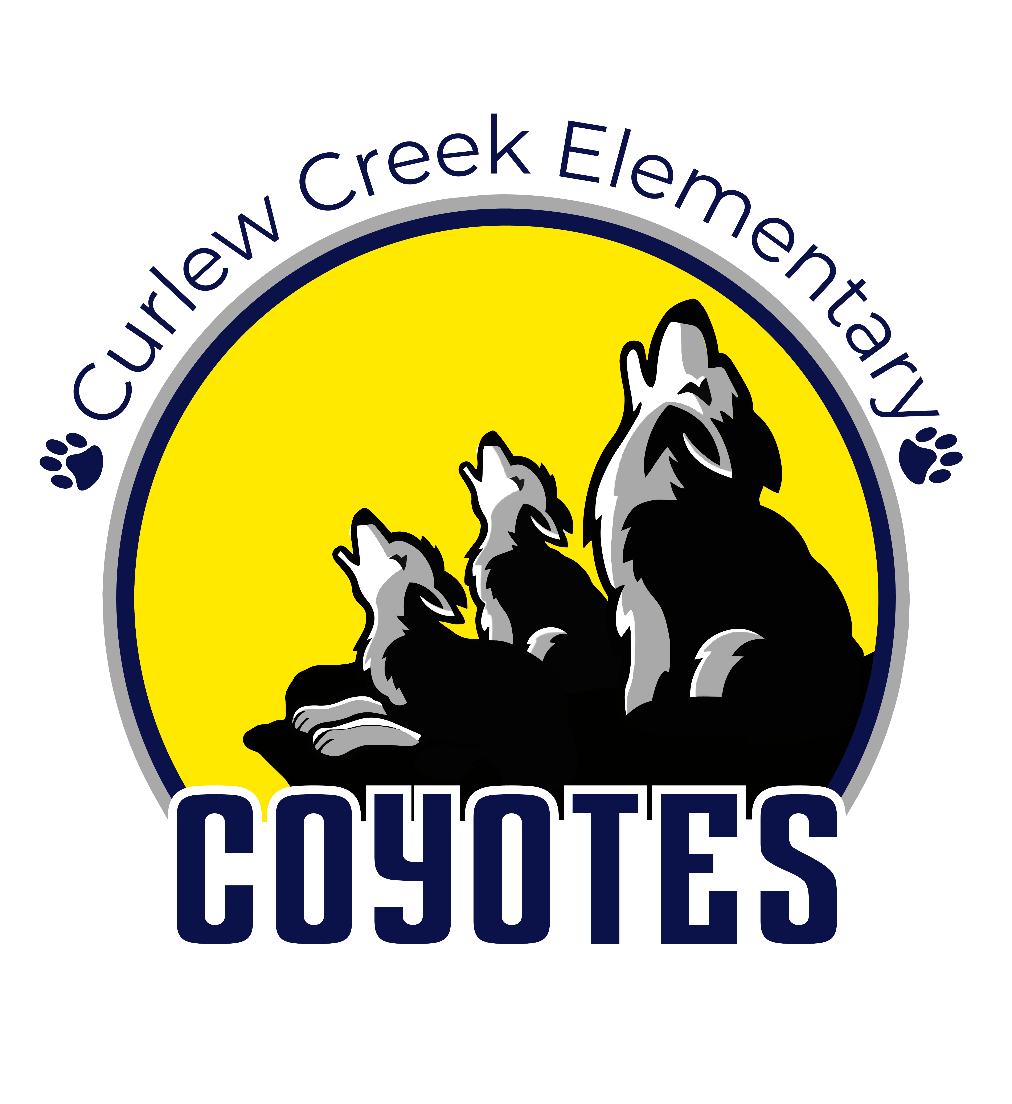

**Curlew Creek Elementary School Advisory Council (SAC)**

**Agenda Items 2024-2025**

**Fridays (or as indicated below) 7:30-8:30 AM**

1. **August 30**

* Introduce Officers
  + Chair – Rachel Brown
  + Co-chair – Madeline Barnes
  + Secretary – Nicole Pesci
  + Parliamentarian – Faith Worley
* Overview of SAC
* 2024-2025 School Improvement Plan (SIP) overview
* Input for topics of interest for 2024-25 agenda

1. **November 8**

* PTA Overview
* Reading/Writing learning updates from students
* ELP (Extended Learning Programs)

1. **February 20** (Thursday)

* Math/Science learning updates from students
* Positive Behavior Support Program
* School Mid-year Data
* Appoint Nominating Committee

1. **April 11**

* Elections / Approve Slate of Officers
* Debrief 2024-25
* 2025-26 School Improvement Plan Input